**SUPPLY CHAIN MANAGEMENT**

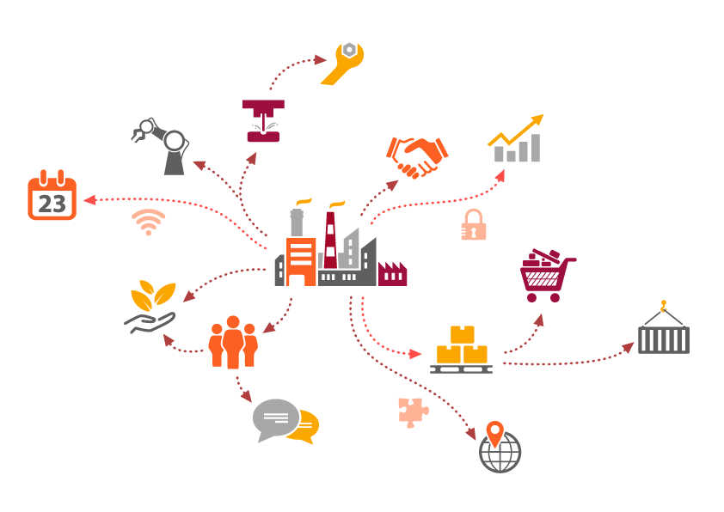

*Goal & Objective: The objective of this exercise is to build a model, using historical data that will determine an optimum weight of the product to be shipped each time from the respective warehouse.*

**Milestone 1:**

**1:** Suggest the probable business impact of each independent feature on the target.

The scenario taken here by the management is to determine the optimum weight of the product to be shipped from the warehouse. So the target coumn here is “Product_wg_tons”.This is a regression type analysis.Here we have 24 columns.

I first consider the columns which has no direct relationship with our target column. we can drop those columns during our feature engineering process.Its description will be as below.

* WH_Manager_Id:It refers only the manager id of each warehouse.
* Warehouse_owner_type: The warehouse is owned by the company or it is on rent.
* Flood_proof:It indicates Warehouse having flood proof or not.The same warehouses approved as floodproof are shown as “ 1 ” in some of the flood affected area columns.So we can neglect it.
* Wh_est_year: It has 50% of null values and not an important column.
* Approved with govt certificate:Even A+ rated warehouses faced more number of breakdown issues,storage issues & also lack of power supply scenario.So it can’t be related to our target.

Now let’s discuss the remaining columns:

•Warehouse_Id:

It’s the identity of the warehouse and not much related to the target .

•Location_type:

Here urban and rural areas included.In Usual case urban areas have more demand of noodles product than rurel and it has a direct relationship with the target column.

•WH_capacity_size:

When high demand happens ,first we are checking the capacity of the warehouses and will fill maximum no. of goods.So its an important column.

•Zone, WH_regional_Zone, Transport_issue per 1y , Distance_from_hub :

All these 4 column describes te geographical conditions and issues facing during the transportation of the product.It will become a price deciding factor of our product.

•Number of refill_requests per 3months:

It gives the refill request happening between 3 months gap and it’s a direct indicator of the demand of the product .Its strongly correlated with our target .

•Competitor in market , Retail_shop_numbers, Distuributers_number:

These 3 columns shows the competing strategy we should taken. Many of the marketing ideas are implemented here for the better growth of the company. Also discounts and offers we can given here for high sales.It has a direct relationship with target column.

•Flood impacted:

This means warehouse is in flood impacted area or not. This has a relationship with target.

•Workers_num,electric supply, Storage_issue_reported_l3m, Temp_reg_mach, Wh_breakdown_l3months:

Above all columns gives the quality and quantity parameters of our warehouse.It also gives the production capacity and the safety measures of the same.These columns have a direct relationship with our target column. A reputed company should have the facilities to satisfy the demand in time base and qualitybase.

•Product_wg_tons :

It gives the Product weight in tons.Its the target.

**2** .Suggest ways in which the organization can benefit as a result of analyzing the data.

By analyzing I inferred some of the points which may improve the organization performance and they are,

* Power stability:

While considering an industry, supply of the electricity is a primary factor.Only through proper power management we can satisfy our day to day functioning and also the automation kind of operations. Automation of a factory or warehouse will ensure the fast and quality output which will improve the overall performance.

Also when we need to implement cold storage facilities, we should update the premises with proper power connections. All these can eliminate the demand supply mismatch up to a level.

* Next one is by providing a suitable solution for the issues like warehouse breakdown, temperature regulating machine indicator ,storage problems of the consignments I think we can stabilize the availability of the product.
* Proper business understandings:

By increasing the number of retail shops, optimizing the number of distributers ,finding better transportation methods its possible to spread the business and can reduce the price factor.

Also we should have a clear understanding of our competitors and the present scenario of the market. Then only a company can make the proper analysis and implement innovative ideas around their product.

* Expansion of the business:

Through proper advertisement channel concentrating on those areas where noodles like fast food cultures are rarely reached ,company can own a new range of customers. This also includes promotion of the product by giving small toys like things which can attract child customers and though that its possible to reach adult ones too.

**3**. Suggest missing features that can help with the analysis based on business logic.

I inferred 2 missing values here:

* Amount of supply happened:

We can inferred the demand value through “number of refill requests “ and ”competitors”. But there is no such columns which can direct related to ‘how amount of supply has done?’.

There are some columns which can directly affect proper supply like “location type” , “workhouse capacity”, ”zone”, ”transportation issues”, ”flood”, ”storage issues reported”, ”warehouse Breakdown” but no such integer columns which gives the supplied amount.

* Method of transportation:

There must be a method of transportation like road,railway,shipping etc. and we can related it to the pricing of the product. Here its missing.Most convenient and cost effective way is railway transportation.The other factors affecting the pricing factors are transport issues, flood , number of workers and distance from hub.

**4.** What is the best way to collect data for the suggested features ?

We inferred 2 missing values and it will be a misguiding of the dataset if we derived anything from the existing set without communicating with the company management. So its better make a direct contact with the company for further implementation.

THANK YOU